**DSD LAB REPORT**

# LAB # 04



# Spring 2021

[**CSE-308L Digital System Design Lab**](https://classroom.google.com/u/0/c/MzA5OTAyNzE2MzM2)

Submitted by: **Hurair Mohammad**

Registration No.: **18PWCSE1657**

Class Section: **B**

“On my honor, as student of University of Engineering and Technology, I have neither given nor received unauthorized assistance on this academic work.”

Student Signature: ______________

Submitted to:

# Engr. Madiha Sher

Department of Computer Systems Engineering

University of Engineering and Technology, Peshawar

**OBJECTIVES:**

This lab will enable students to:

* Code using Behavioral level modeling
* Implement an 8 Bit Ring Counter

**TASK:**

**Implementation of an 8-bit Ring Counter**

**CODE:**

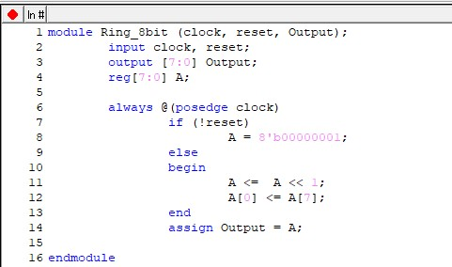

**TestBench:**

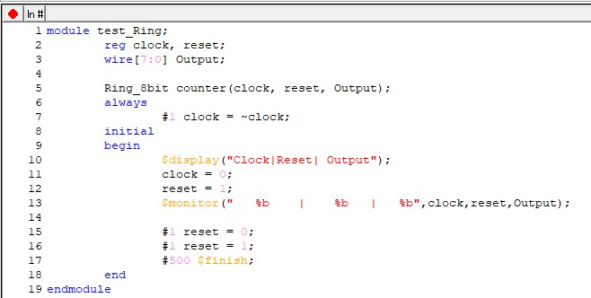

**OUTPUTS**

**Truth Table:**

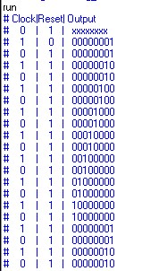

**Data Flow:**

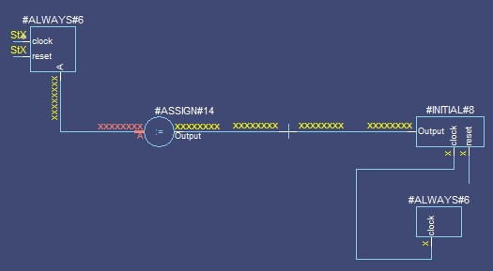

**Wave Form**

**:**

